# Analysis of Position-Dependent Compton Scatter in Scintimammography With Mild Compression

Deepa Narayanan, Mark B. Williams, Mitali J. More, Stan Majewski, Doug Kieper

## Introduction:

During the past several years, we have been developing a breast scanning system that combines digital x-ray mammography with breast scintigraphy using a dedicated small field of view gamma camera. The x-ray and gamma ray detectors are mounted on an upright mammography gantry, and the x-ray transmission and gamma emission views are obtained sequentially while the breast is held in a fixed configuration using mild compression. The chest wall edges of the x-ray and gamma ray detectors coincide, and the gamma camera is centered left-to-right within the field of view of the x-ray detector. The fields of view of the gamma camera and x-ray detector are 10 cm x 10 cm and 19 cm x 28 cm, respectively. In an ongoing clinical evaluation, the resulting dual modality images have proven effective for differentiation of benign and malignant breast masses, compared to prone scintimammography alone with our dedicated camera.

In a typical gamma image acquisition using the dual modality system, a two-dimensional image histogram is updated each time a gamma interaction occurs which deposits an amount of energy in the detector that falls within a predetermined energy window. However, in a number of recent patient studies, gamma emission data were acquired in list mode rather than in the conventional single histogram mode. In list mode, the location on the detector surface of the gamma ray interaction and the total energy of the interaction are stored for each detected gamma event individually. The resulting list of x, y, E triplets can then be replayed with any desired energy discrimination criteria. In addition, energy spectra corresponding to any arbitrary region of the detector surface may be obtained. We have used this capability to study the spatial dependence of the Compton scatter coming from the breast. Our goal is to determine whether generalized conclusions regarding scatter-to-primary ratios at various locations within the breast are possible, and if so, to use them to make explicit scatter corrections to the breast scintigrams.

## Methods:

Volunteers were recruited for an IRB-approved ongoing study of the dual modality scanner as a diagnostic adjunct to screening mammography. For the scatter study, the discriminator threshold that triggers the analog-to-digital converters was set just above the electronic noise, so that gamma rays Compton scattered through even large angles were counted. Energy spectra were obtained for five contiguous regions of interest (2 cm x 2 cm) centered left to right, and extending from the chest wall edge of the image to the anterior edge (see Figure 1). To help analyze these spectra, an anthropomorphic torso phantom with fillable internal organs was used. The concentrations of 99m-Tc solution in the lungs, heart, liver, and torso were 0.51, 1,3.9, and 0.33 μCi/cc, respectively. A simulated compressed breast (5 cm thickness) was attached to the chest of the phantom, and positioned as in a typical dual modality breast scan. The phantom breast was filled with water, and contained no radioisotope, thus spectra obtained for the five ROI’s contained only contributions from Compton scattered gamma rays, and no full energy (140 keV) events. This process was repeated with both left and right breast phantoms to account for spectral differences due to the heart and liver. We also obtained a scatter-free 99m-Tc energy spectrum using a point source. For each ROI, the measured patient energy spectrum was fit with a linear combination of the scatter-only spectrum from the anthropomorphic phantom and the scatter-free spectrum from the point source. The resulting coefficients were used to calculate the average fraction of events in each ROI due to scatter for a given energy window. These scatter fractions were then attributed to pixels lying in the center of the ROI, and interpolation between these values resulted in a pixel-by-pixel correction matrix for the breast scintigrams.

## Results:

Figure 2 shows typical energy spectra taken from the first, third and fifth ROIs shown in Figure 1. The spectra were obtained from a normal breast. The shapes of the Compton component were similar between the patients studied, however the relative fractions of scatter and primary differed, primarily due to differences in breast size. It is clear from the spectra of Figure 2 that a) Compton scattered events comprise most of the events, and b) the fraction of scattered gamma rays in the spectrum increases with decreasing distance from the chest wall. Figure 3 shows the scatter-only spectra from the same ROI’s, obtained using the anthropomorphic phantom with no activity in the breast.

## Conclusions:

Compton scatter comprises a large fraction of the detected events in compressed breast scintimammography. Although there is a very strong dependence on location within the breast of the scatter-to-primary ratio, the spectra are well modeled by a linear combination of scatter-only and scatter-free spectra. For each ROI, the measured patient energy spectrum was fit with a linear combination of the scatter-only spectrum from the anthropomorphic phantom and the scatter-free spectrum from the point source. Our results so far indicate that useful scatter corrections can be made based on position-specific energy spectrum measurement and realistic scatter data from the anthropomorphic phantom. Although we certainly expect the most significant change in spectral composition in the direction from chest wall to anterior, we are currently in the process of evaluating possible change in spectral shape in the left-right direction, and also are undertaking a comparison between left and right breast spectra from the same patient.

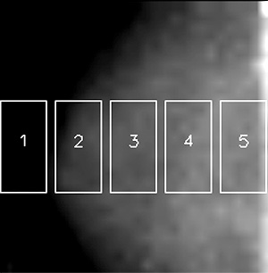

Figure 1: Example breast gamma image showing 5 ROIs.

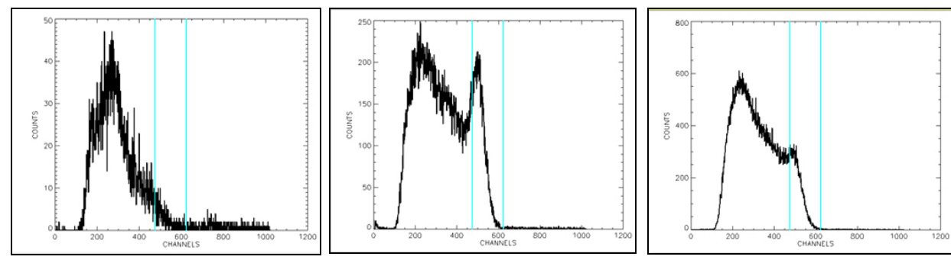

Figure 2: Energy Spectra from ROIs 1,3 and 5. The two vertical lines indicate the energy window used in the acquisition (-5%/+22%). The spectrum from ROI 1 contains almost no primary counts because it was located beyond the anterior edge of the breast.

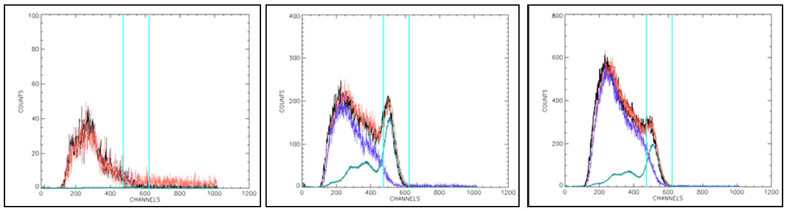

Figure 4 : Fits between energy spectra obtained from a patient (black) and the linear combination of scatter-only and scatter-free spectra (red). The blue line is the scaled scatter spectrum and the green line is the scaled primary (scatter-free) spectrum. These represent spectra from ROIs 1, 3 and 5.



Figure 3: Scatter-only energy spectra from ROIs 1,3 and 5 obtained using the anthropomorphic phantom



Figure 4 : Fits between energy spectra obtained from a patient (black) and the linear combination of scatter-only and scatter-free spectra (red). The blue line is the scaled scatter spectrum and the green line is the scaled primary (scatter-free) spectrum. These represent spectra from ROIs 1, 3 and 5.

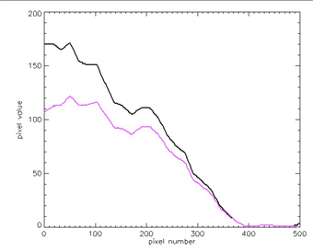



Figure 5: Profiles through the breast image. The black line shows a profile through the center row of the gamma image (shown in Figure 1). The pink line is a profile through the same row after scatter correction

Figure 5: Profiles through the breast image. The black line shows a profile through the center row of the gamma image (shown in Figure 1). The pink line is a profile through the same row after scatter correction